CFS - Rickettsial Infection - Case Studies by Dr. Cécile Jadin, South Africa

Summary: Since January 1991, over 3.000 patients, previously diagnosed as ME, CFS, psychopathic, fibromyalgia, arthritic diseases, or unknown, were treated with Antibiotherapy. The reason for this treatment was as follows:
- The symptoms of these patients were similar to those exhibited in chronic Rickettsial diseases.
- The treatment followed the finding that their serum reacted positively to the Giroud micro- agglutination test.

Giroud Test - specific for testing antibodies
to these 5 antigens (R36):

- Rickettsia Prowazeki
- R. Mooseri
- R. Conori
- Coxiella Burnetti
- Neo-R. Q18 (R50)

Done by micro agglutination

Depends on the quality of antigens

Comparative studies with IFA test gave very similar result
- Positive reaction = presence of antibodies;
(does not necessarily mean illness)
- Negative reaction does not suppress Rickettsial etiology (R1,25)

BECAUSE
- The occult infection is biologically similar to the disease itself (Ch. Nicolle) (R2, R34)
- Walker and Jadin described positivity for Rickettsiae on people without any symptoms (26% according to Walker) (R3, R9, R25, R45)
- If doubtful and if negative, the test should be repeated to follow the antibody curve (R37)
- Same applies for many pathogenic agents e.g. coxsackies (R38), chlamydiae pneumoniae (R39) etc.
THEREFORE

the diagnosis of Rickettsial disease stands on 3 corner stones:

Symptoms Clinical findings Biological investigations

Patients and Methods: Statistics of 500 patients (100% Caucasian)

Criteria for selection: first dsed as ME, CFS, or Depression
Sex |  |  | Age | Group |  | Length of Illness:
Male: | 236 |  | <10: | 2.1% |  | < 1 year: | 12.5%
Female: | 264 |  | 10 - 20: | 16.7% |  | 1 - 2 years: | 20.7%
 |  |  | 20 - 40: | 43.7% |  | 2 - 5 years: | 29.3%
 |  |  | > 40: | 37.5% |  | > 5 years: | 37.5%

Exposure to Rickettsia: | Known: | 95%
 | Unknown: | 5%
- Rickettsia infection symptoms and diseases according to tissue type:
Vascular Tissue |  |  | Reticulo Endothial |  | Tissue
Tiredness (R1,4,7,9,13,28) | 92% |  | Recurrent sore throat (R1) |  | 85%
Myalgia Arthralgia (R5) | 90% |  | Appendicitis (R5,8) |  | 65%
Cardiac. Valves  R1,6,7,8,9) | 90% |  | Lymphadenopathy (R1) |  | 73%
Memory. Concentration (R9) | 89% |  | Systemic Candidosis |  | 53%
Headaches (R1,9) | 88%
Bruising (R26) | 81% |  | Neurological | Tissues
Vision - Uveitis Conj. (R1) | 39% |  | Encephalitis (R1,11,13,17) |  | 12%
Dermatological (R9,10) | 23% |  | Epilepsy (R1,13,24) |  | 69%
Psychotic disorder treated (R9) | 69% |  | MS (R4,9,24,37) |  | 5%
Atypical Hepatitis (nausea-vom.) (R1,11,12,27,31) | 64% |  | Loss of Balance |  | 28%
Raynaud Syndrome (R13) | 69%
Pulmonary Disease (R6,8,14,31) | 21%
HBP | 9%
- Clinical Examination

- Biological Investigations
- CXR - MRI (Brain Scan) - Joint X-Ray
- Treatment: average of 7 days/month of Tetracyclines
1.alternated (R6,9,11,28)
2. combined with Quinolones, Macrolides, Metronidazoles (R6,43)
3. high dosage (R1,9,11,13,43)
4. varying in length (fast response, slow response) (R1,9,13,16,25,43,45,48)
5. Anti malaria
6. Adjuvants
7. Exercise (Rickettsia has vascular impact) and hot baths (R9)
- Herxheimer reaction: Prognosis value (R1,11,18,44,47)
- Results - Statistics:
Including patients not treated, or treatment not completed
358 patients very well, or cured |  | 72%
101 patients stopped consultation after 1 to 3 treatments |  | 20%
26 patients never commenced treatment |  | 5%
15 patients showed no improvement to treatment |  | 3%
Excluding patients not treated or treatment not completed
:358 patients very well, or cured | 96%
101 patients stopped consultation after 1 to 3 treatments | 4%

NB:
% of reactivation or reinfection of patients well improved: 7%
- , but patients recover after further treatment (2 to 3 months average) (R25,26)

- This Assessment is performed monthly to judge patients progress towards "very well" : symptoms meaurement
increase in activity
symptomatic medication independence (pain killers, anti-depressants, hypnotics, cortisone)
medical examination
biological investigation.
Based on this, the treatment is prolonged or stopped (3 months to 2 years - 8 months average).
However, length of treatment is not directly correlated to the length of illness.
Patients can be divided into 2 categories:
1. Fast progress - their illness was mainly Rickettsia
2. Slow progress - their illness was Rickettsia plus other factors (R36)
- Followup - was done by means of research questionnaire sent to patients on or off treatment every 6 months for 2 years (1992-1993). 78% answered, and of those, 93% were still "very well".
- Discussion:
- CFS in Nevada (R40) - Rocky Mountain fever (R7,8)
- CFS - Nightingale disease (R33)
- Lymphocyte study results similar in sheep with tick-borne diseases and in patients with CFS (R19,21,22,23) and patients with Q Fever endocarditis (R48)
- CFS - PQFS (R4)
- Rickettsial Disease through History (R7,8)
- Treatment rates success (R28)
- Interaction between protozoa, viruses, bacteria, and stress? (R9,29,34,36,42)
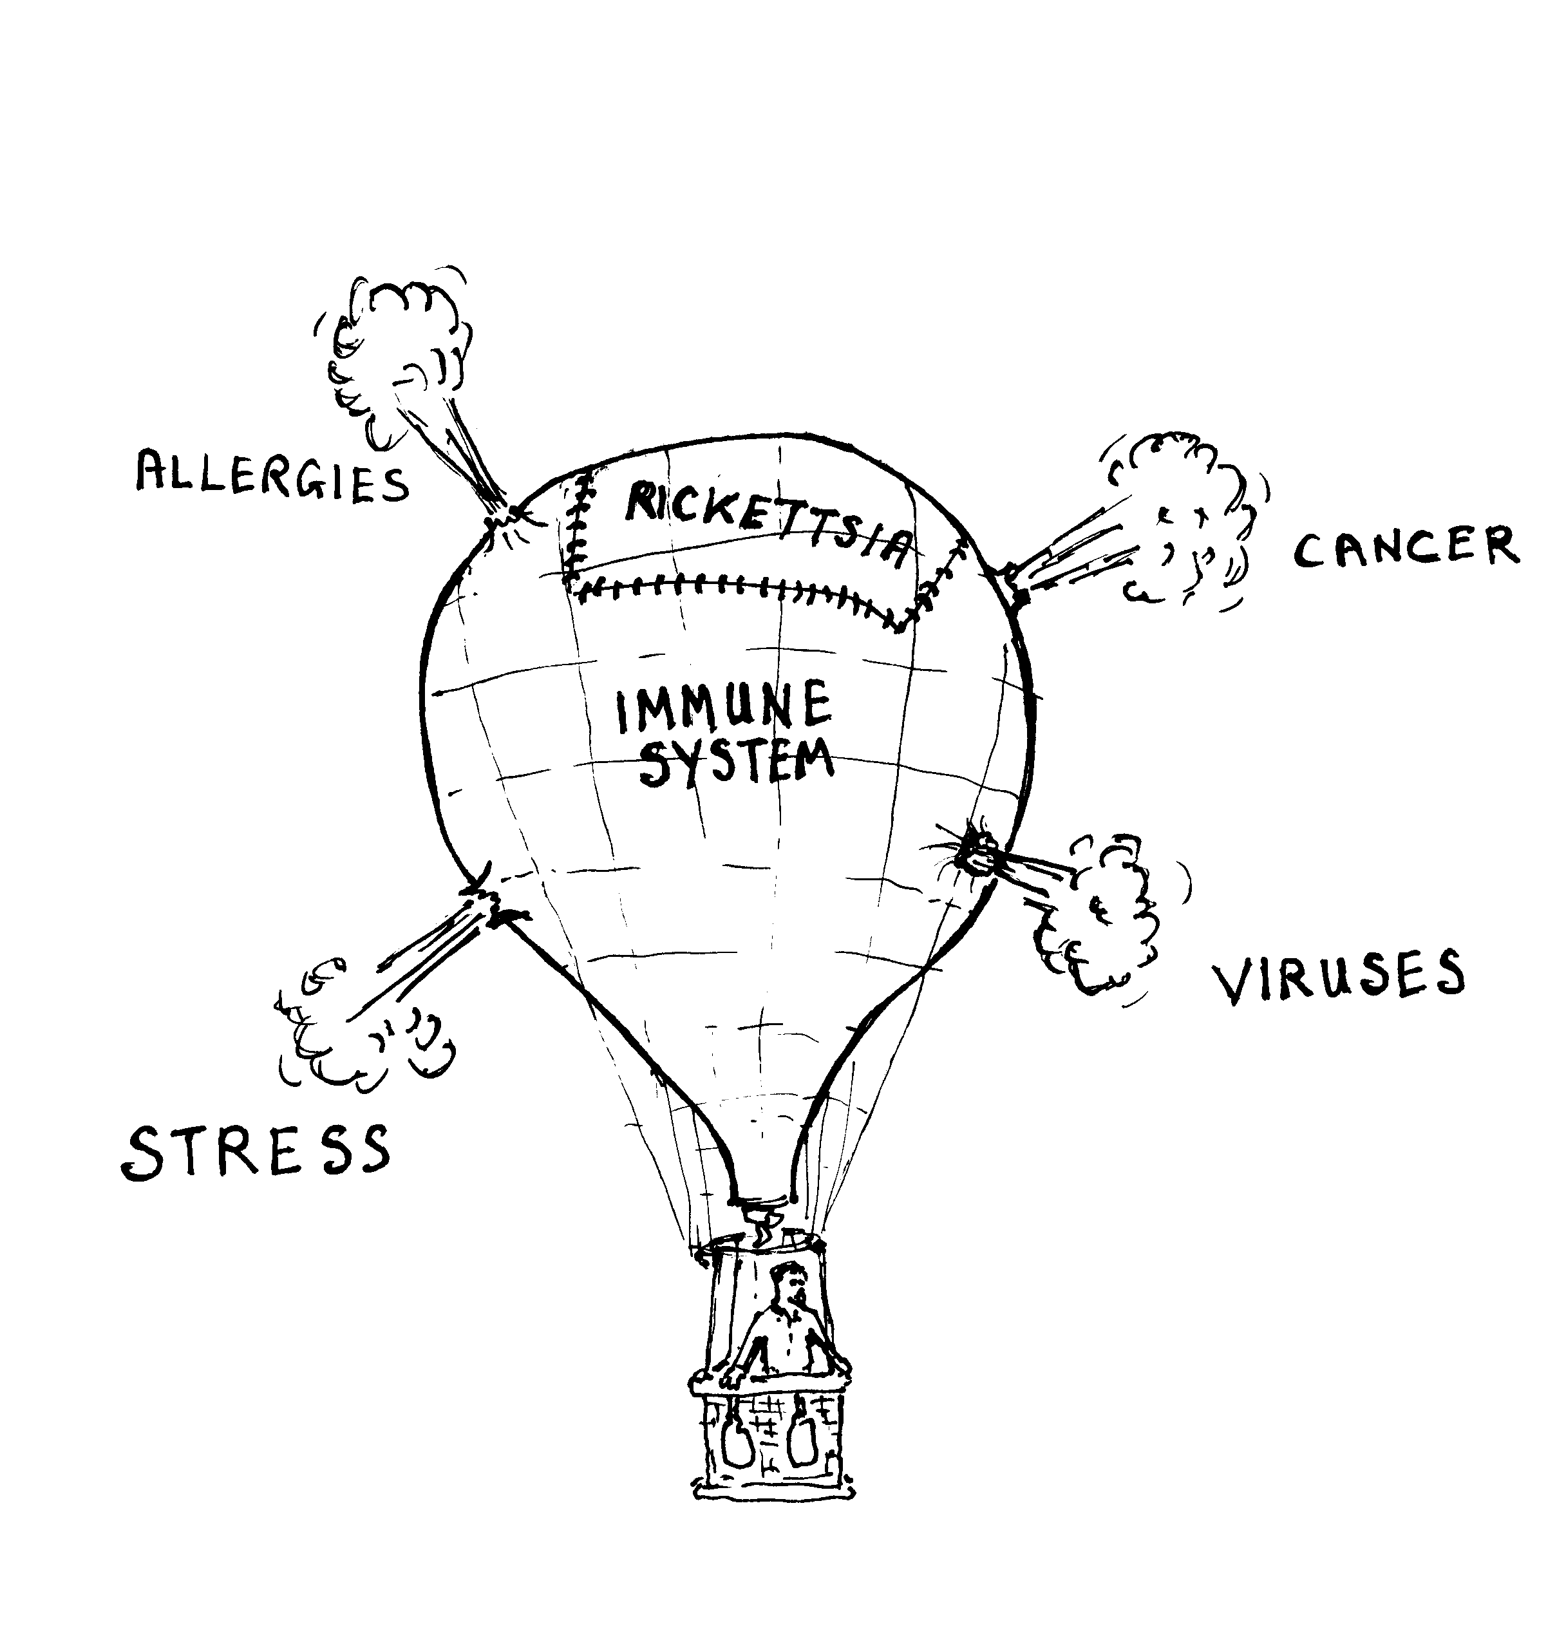
Rickettsia
is a suggested way
to repair an Immune System,
quickly or slowly.

"La santé est comme une mongolfière: il faut parfois lâcher du lest"

